PIZZA SALES SQL QUERIES

A.Kpi’s

1.Total Revanue

SELECT SUM(total_price) AS Total_Revanue FROM pizza_sales

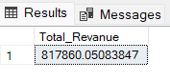

2.Average order value

SELECT SUM(total_price)/COUNT(DISTINCT order_id) AS Avg_order_value FROM pizza_sales

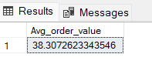

3.Total pizzas sold

SELECT SUM(quantity) AS Total_pizzas_sold FROM pizza_sales

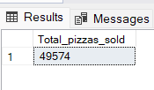

4.Total orders

SELECT COUNT(DISTINCT order_id) AS Total_orders FROM pizza_sales

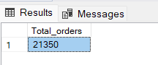

5. Average pizzas per order

SELECT CAST(CAST(SUM(quantity) AS DECIMAL(10,2))/CAST(COUNT(DISTINCT order_id) AS DECIMAL(10,2)) AS DECIMAL(10,2)) AS Avg_pizzas_per_order

FROM pizza_sales

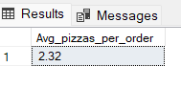

6.Total sales by category wise

SELECT pizza_category,

SUM(total_price)*100/(SELECT SUM(total_price) FROM pizza_sales) AS PCT_sales_category_wise

FROM pizza_sales

GROUP BY pizza_category

ORDER BY PCT_sales_category_wise

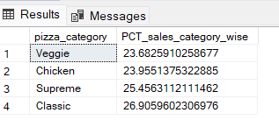

7.Percentage sales by pizza size

SELECT pizza_size,

SUM(total_price)*100/(SELECT SUM(total_price) FROM pizza_sales) AS PCT_size_wise

FROM pizza_sales

GROUP BY pizza_size

ORDER BY PCT_size_wise DESC

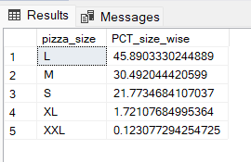

8.BEST 5 SALLER

SELECT TOP 5 pizza_name, SUM(total_price) AS top_saller FROM pizza_sales

GROUP BY pizza_name

ORDER BY top_saller DESC

